

**SUBMITTED BY:**

**VERNIKA SAINI**

**CU240141005**

**SUBMITTED TO:**

MR. SOURABH POSWAL

**Title: - Zomato Restaurants Analysis**

**Name: - Deepakshi Sharma Registration number: - CU240140541 Course and semester: -MBA- 1st ‘B’ Semester Submission date: - 2024**

**Faculty/guide name: - Mr. Sourabh Poswal**

**DASHBOARD**

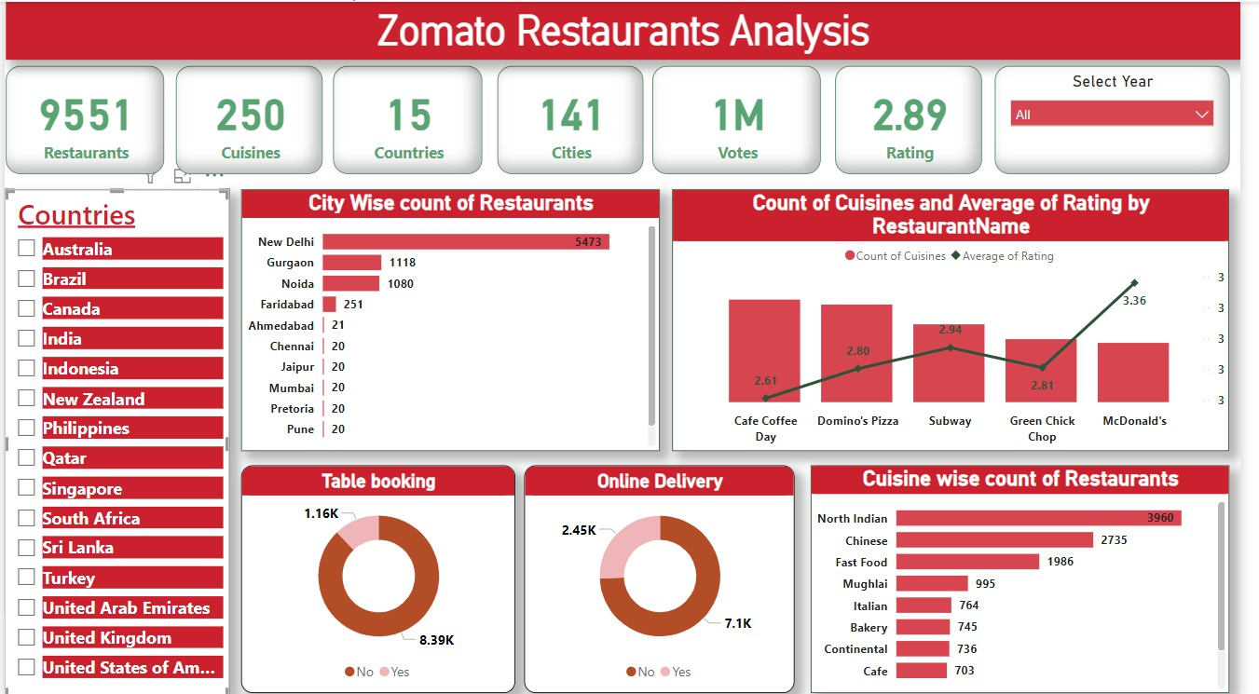

# Executive Summary

This report provides a comprehensive analysis of Zomato's restaurant data using a visually engaging and interactive Power BI dashboard. The primary objective is to extract actionable insights that Zomato can leverage to optimize its operations, enhance customer satisfaction, and capitalize on growth opportunities in the competitive food delivery and dining industry.

The analysis is based on a dataset encompassing **9,551 restaurants** across **15 countries**, **141 cities**, and offering **250 different cuisines**. The data spans multiple facets of Zomato’s operations, including restaurant distribution, customer preferences, service trends, and engagement metrics. The key findings and recommendations from the analysis have significant implications for Zomato’s strategic planning and business growth.

# Key Highlights

1. **Restaurant Distribution**
   * The dataset reveals Zomato's extensive presence in **15 countries**, with India emerging as the dominant market. Cities such as **New Delhi**, **Gurgaon**, and **Noida** feature the highest number of restaurants, reflecting strong market penetration.
   * Smaller cities like **Ahmedabad** and **Pretoria** are underrepresented, presenting opportunities for expansion.

# Cuisine Trends

* + **North Indian**, **Chinese**, and **Fast Food** are the most popular cuisines, catering to a broad customer base.
  + Specialty cuisines like **Italian**, **Continental**, and **Bakery** appeal to niche markets, indicating potential for targeted marketing and premium offerings.

# Customer Engagement

* + The average rating across all restaurants is **2.89**, signaling room for improvement in service quality. Leading brands like **McDonald’s** score significantly higher, showcasing the potential to replicate their successful strategies across other restaurants.
  + High vote counts highlight active customer engagement with popular brands.

# Service Trends

* + **Online delivery** is the preferred mode of service, with over **7,100 customers** opting for it, underscoring its critical role in Zomato’s business model.
  + While **table booking** is less popular, it offers a niche market opportunity, particularly for premium or experiential dining.

# Opportunities for Growth

* + Zomato can explore expansion into cities with low restaurant counts, develop partnerships with underperforming restaurants, and introduce innovative services to enhance customer satisfaction.
  + By diversifying menu offerings and improving underperforming restaurants, Zomato can attract more customers and boost retention.

# Strategic Recommendations

* **Focus on Online Delivery**: Enhance delivery efficiency and introduce premium or subscription- based delivery services to cater to high-demand regions.
* **Improve Service Quality**: Partner with restaurants to address low ratings, train staff, and enhance customer experiences.
* **Expand Market Presence**: Target underrepresented cities like **Faridabad**, **Ahmedabad**, and

**Pretoria** for growth initiatives.

* **Diversify Cuisine Offerings**: Encourage partner restaurants to add trending cuisines to their menus, appealing to a broader audience.
* **Leverage Data for Partner Support**: Provide restaurant partners with insights on customer preferences and performance benchmarks to improve their services.

# . Project Objectives

1. **Comprehensive Restaurant Analysis**
   * To map and analyze the global distribution of Zomato's restaurants across **15 countries** and **141 cities**.
   * Identify cities and regions with the highest and lowest restaurant density to prioritize areas for investment, improvement, and growth.

# Understanding Cuisine Preferences

* + To evaluate the popularity of **250 different cuisines** offered by Zomato-listed restaurants, determining which cuisines are most in demand.
  + Analyze customer preferences for cuisines at both local and global levels, helping Zomato align its offerings with consumer tastes.
  + Recommend underrepresented cuisines with growth potential based on trends and demand in various regions.

# Evaluating Customer Engagement

* + Assess customer engagement metrics such as ratings (**average of 2.89**) and votes to identify patterns in customer satisfaction.
  + Determine which restaurants or brands perform better in terms of customer satisfaction and engagement.
  + Use these insights to guide restaurants in improving service quality and customer experiences.

# Assessing Service Preferences

* + Analyze trends in customer preferences for **online delivery** and **table booking**, helping Zomato understand the relative demand for each service type.
  + Provide actionable insights for enhancing these services:
    - Optimize online delivery logistics to handle increasing demand efficiently.
    - Explore opportunities to promote table booking in cities or markets where dine-in culture is prevalent.

# City-Wise and Regional Insights

* + Conduct a **city-wise analysis** to identify cities with the highest restaurant counts (e.g., **New Delhi**, **Gurgaon**) and potential growth areas with lower representation (e.g., **Ahmedabad**, **Pretoria**).
  + Understand regional differences in customer behavior, service usage, and cuisine preferences to customize marketing and operational strategies.

# Performance Benchmarking

* + Benchmark the performance of top restaurant brands (e.g., **McDonald’s**, **Domino’s Pizza**) based on metrics like ratings, votes, and service offerings.
  + Highlight areas where underperforming restaurants can improve by learning from high-performing counterparts.
  + Provide performance metrics to help Zomato support restaurants with data-driven recommendations for better customer engagement.

# Data Visualization and Storytelling

* + Develop an interactive, visually appealing **Power BI dashboard** to present complex data in a user- friendly format.
  + Enable Zomato's leadership team to quickly understand insights and make data-driven decisions through intuitive visualizations.
  + Ensure the dashboard can be updated with new data for real-time monitoring and reporting.

# Supporting Strategic Growth

* + Help Zomato identify potential markets for expansion by analyzing restaurant density and customer demand in different countries and cities.
  + Highlight trends in low-performing regions and recommend strategies for improving Zomato's presence and customer reach in those areas.
  + Provide insights for targeted marketing campaigns to attract customers in underserved locations.

# Improving Customer Satisfaction

* + Identify the factors influencing customer ratings and votes to recommend improvements in service quality and menu offerings.
  + Help restaurants address customer complaints and enhance the overall dining or delivery experience.
  + Use customer engagement data to predict trends and proactively address potential challenges.

# Driving Revenue Growth

* + Identify key revenue drivers, such as high-demand cuisines and popular delivery services, to guide resource allocation and investment.
  + Optimize service offerings to increase customer retention and order frequency.
  + Use insights to create tailored promotions and loyalty programs that boost Zomato's overall revenue.

# Promoting Sustainability and Scalability

* + Ensure that Zomato's operations are scalable by identifying trends and gaps in service delivery, customer behavior, and market saturation.
  + Develop insights that promote sustainable growth, focusing on long-term customer satisfaction and operational efficiency.
  + Lay the groundwork for Zomato to adapt to emerging trends in the food and dining industry.

# Delivering Value to Stakeholders

* + Provide valuable insights to restaurant partners, enabling them to improve their performance, expand their reach, and better cater to customer preferences.
  + Strengthen Zomato's position as a trusted partner for restaurants and as a leading brand in the food delivery industry.
  + Use data insights to enhance Zomato's appeal to investors, stakeholders, and customers by showcasing operational excellence and innovation.

**Key Findings**

1. **Restaurant Distribution**
   * **High Density in India**:

India is the leading market for Zomato, with cities like **New Delhi (5,473 restaurants)**, **Gurgaon (1,118)**, and **Noida (1,080)** having the highest concentration of restaurants.

# Low Density in Some Cities:

Cities such as **Ahmedabad (21)**, **Faridabad (251)**, and **Pretoria (20)** have significantly fewer restaurants, presenting potential opportunities for expansion.

# Popular Cuisine Preferences

* + **Top Cuisines**:
    - **North Indian (3,960 restaurants)**, **Chinese (2,735)**, and **Fast Food (1,986)** are the most popular cuisines, catering to the majority of customer preferences.
    - This indicates strong customer demand for these cuisines, which Zomato can further promote through partner collaborations.

# Niche Cuisines:

* + - Cuisines like **Italian (764 restaurants)**, **Continental (745)**, and **Cafe (703)** are less common but show consistent demand.
    - These cuisines present opportunities for targeting premium and niche audiences.

# Service Trends

* + **Online Delivery Dominates**:
    - Over **7,100 customers** opt for online delivery, indicating its critical importance in Zomato’s service offerings.
    - The consistent growth of this segment highlights the need to invest in delivery efficiency and reliability.

# Table Booking is Limited:

* + - Only **1,160 customers** use the table booking feature compared to 8,390 who do not. This suggests limited interest in table bookings but highlights potential opportunities in specific regions or for specific dining experiences.
    - Promotions or exclusive offers for table bookings could drive growth in this area.

# Customer Engagement and Satisfaction

* + **Average Ratings**:
    - The overall average rating is **2.89**, indicating room for improvement in customer satisfaction.
    - Restaurants and brands like **McDonald’s (3.36)** consistently achieve higher ratings, providing benchmarks for quality and customer service.

# Voting Trends:

* + - High numbers of votes in popular restaurants indicate active customer engagement, which can be leveraged for targeted campaigns and promotions.

# Market Insights

* + **High-Performing Regions**:
    - Cities like **New Delhi** and **Gurgaon** are Zomato’s strongholds, offering opportunities to pilot new features, cuisines, or services.
    - These cities also present opportunities to cross-sell premium services like subscription plans or exclusive dining experiences.

# Underrepresented Areas:

* + - Cities with fewer restaurants, such as **Ahmedabad**, **Pretoria**, and **Faridabad**, present opportunities for market penetration.
    - Expanding in these cities can diversify Zomato’s customer base and improve its market presence.

# Cuisine Trends by City

* + In cities with high restaurant counts, cuisines like **North Indian** and **Chinese** dominate, but there is potential to introduce more diverse options to cater to niche audiences.
  + For example, cities like Gurgaon and Noida could benefit from expanding **Italian** or **Continental**

options, tapping into upscale customer preferences.

# Brand and Restaurant Performance

* + **High-Performing Brands**:
    - Brands like **McDonald’s**, **Domino’s Pizza**, and **Subway** lead in terms of customer ratings and votes, indicating strong brand loyalty and customer satisfaction.

# Low-Performing Brands:

* + - Restaurants with below-average ratings represent areas where Zomato can step in to help improve service quality or offerings.

# Revenue Opportunities

* + **Online Delivery as a Revenue Driver**:
    - The popularity of online delivery makes it a key revenue stream for Zomato. Expanding delivery zones and improving delivery times could boost customer satisfaction and repeat orders.

# Underexplored Services:

* + - Table booking, while less popular, presents a niche opportunity for revenue, especially in areas where dine-in culture is stronger.

# Opportunities for Partner Restaurants

* + Restaurants can optimize their menus based on the popularity of cuisines in their respective regions.
  + Low-performing restaurants can improve ratings and customer engagement by analyzing customer feedback and focusing on high-demand cuisines.

# Growth Opportunities

* + **Regional Expansion**:
    - Cities with fewer restaurants, such as **Pretoria** and **Ahmedabad**, can be targeted for growth initiatives.

# Cuisine Diversification:

Introducing fewer common cuisines in cities with high competition can differentiate Zomato’s offerings and attract niche audiences

**Table of Contents**

1. Introduction 9
   1. Case Background and Problem Statement 9
   2. Objectives of the Analysis 10
   3. Report Structure and Limitations 11
2. Research Methodology 11
   1. Data Sources Used 11
   2. Approach for Data Collection and Cleaning 12
   3. Tools and Technologies Utilized 12
3. Business Intelligence in Zomato 13
   1. Overview of Business Intelligence Applications 13
   2. Importance of Business Intelligence in Food Tech 13
   3. Power BI as an Analytical Tool 14
4. Key Insights from the Analysis 14
   1. Restaurant and Cuisine Overview 15
   2. Service Insights (Online Delivery and Table Booking) 15
   3. City-wise and Country-wise Restaurant Analysis 16
   4. Customer Ratings by Cuisines and Restaurants 17
5. Dashboard Design and Visualization 17
   1. Requirement Gathering and Data Preparation 17
      1. Stakeholder Interviews 18
      2. Market Benchmarking for Design 18
   2. Prototyping and Development 18
      1. Report Design Process 18
      2. Dashboard Interface Development 19
   3. Dashboard Deployment Process 19
      1. Data Integration 19
      2. Creating and Publishing Reports 19
      3. Mobile-Optimized Dashboards 20
   4. Evaluation and Improvements 20
6. Conclusion and Recommendations 20
   1. Summary of Key Findings 20
   2. Suggestions for Business Strategy 21
7. References 21

# Introduction

# Case Background and Problem Statement

Zomato, a global leader in the restaurant aggregation and food delivery industry, operates in over 15 countries and 141 cities, providing diverse cuisines and services to millions of customers. Its platform not only enables users to discover restaurants but also supports services such as table bookings and online food delivery. However, as Zomato's reach has grown, so too have the challenges of managing, analyzing, and leveraging vast amounts of data for strategic decision-making.

# Problem Statement:

Despite Zomato's expansive dataset, there are several challenges that hinder optimal utilization:

* **Fragmented Insights**: Data is often spread across multiple layers, making it difficult to generate actionable insights.
* **Customer Experience**: Variations in services like online delivery and table bookings lead to inconsistent customer experiences.
* **Market Strategy**: A lack of detailed analysis for certain regions and cuisines prevents Zomato from fully capitalizing on growth opportunities.
* **Ratings and Feedback**: While customer ratings are available, they are underutilized in understanding restaurant performance trends.

The goal of this report is to address these issues by analyzing Zomato's restaurant data comprehensively, focusing on key metrics like city and cuisine-wise distribution, service adoption, and customer ratings.

# Objectives of the Analysis

This report seeks to extract actionable insights from Zomato's data to address the identified challenges and guide future strategies. The primary objectives include:

# City-Wise and Cuisine-Wise Distribution:

* + To analyze the distribution of restaurants across cities and cuisines to identify patterns and disparities.
  + To assess the availability of popular and underrepresented cuisines in specific regions.

# Service Insights (Online Delivery and Table Booking):

* + To evaluate the penetration of online delivery and table booking services.
  + To recommend strategies for increasing service adoption.

# Customer Ratings and Feedback Analysis:

* + To correlate restaurant ratings with cuisine popularity and brand performance.
  + To identify high-performing restaurants and areas needing improvement.

# Geographical Analysis:

* + To explore underrepresented cities and countries for potential market expansion.

# Dashboard Visualization:

* + To present findings in an intuitive, user-friendly dashboard using Microsoft Power BI, enabling better data-driven decision-making.

# Report Structure and Limitations Report Structure:

This report is organized as follows:

1. **Introduction**: Provides the case background, problem statement, objectives, and report structure.
2. **Research Methodology**: Describes the data sources, collection methods, and analytical tools used in the study.
3. **Business Intelligence in Zomato**: Explains the role of business intelligence and Power BI in data analysis.
4. **Key Insights from the Analysis**: Presents detailed findings, including city-wise distribution, cuisine popularity, service availability, and customer ratings.
5. **Dashboard Design and Visualization**: Outlines the design and deployment process for the Power BI dashboard.
6. **Conclusion and Recommendations**: Summarizes findings and provides actionable recommendations for Zomato’s strategic planning.
7. **Appendices**: Contains additional data and resources used in the analysis.

# Limitations:

While the analysis provides valuable insights, it is essential to acknowledge certain limitations:

1. **Data Coverage**: The dataset is limited to the information available on Zomato’s platform and does not include offline restaurant data or competitors’ data.
2. **Time Frame**: The analysis focuses on current data and may not reflect historical trends or future projections.
3. **Regional Bias**: With India dominating Zomato’s dataset, other countries may have less representation, affecting global generalizations.
4. **Customer Feedback**: Ratings and feedback are subjective, and the analysis may not fully capture customer sentiments or preferences.

# Research Methodology

# Data Sources Used

The data analyzed in this report was sourced from Zomato's publicly available datasets, which capture extensive details about its restaurant offerings, customer reviews, and service availability across multiple countries and cities. The dataset includes the following key attributes:

# Restaurant Details:

* + Name, location (city, country), address, and contact information.
  + Ownership type (e.g., independent, chain).

# Cuisines Offered:

* + Variety and count of cuisines available per restaurant, ranging from popular options like North Indian and Chinese to niche cuisines.

# Services:

* + Availability of online delivery and table booking.
  + Payment modes accepted, including digital wallets and cash.

# Customer Reviews and Ratings:

* + User-submitted ratings on a 5-point scale.
  + Text-based reviews, where applicable.

# Restaurant Pricing and Votes:

* + Average cost for two people.
  + Number of votes a restaurant has received.

# Geographic Data:

* + Data on cities and countries where Zomato operates, helping to identify hotspots and underserved regions.

The diversity of data ensures that the analysis captures a comprehensive view of Zomato's operations.

# Approach for Data Collection and Cleaning

The following steps were followed to ensure the data was ready for analysis:

# Data Collection:

* + Data was extracted from Zomato’s open datasets and APIs.
  + Additional supplementary information, like regional cuisine trends, was manually collected from relevant industry reports to provide context.

1. **Data Cleaning**: Data cleaning was a critical step to ensure the quality and reliability of insights. Key actions included:
   * **Handling Missing Data**: Rows with essential missing fields (e.g., restaurant name, city) were removed. Missing ratings were replaced with the median rating for that cuisine type in the same city.
   * **Removing Duplicates**: Duplicate entries (e.g., multiple entries for the same restaurant) were identified and removed.
   * **Standardizing Formats**: City names, cuisines, and other categorical data were standardized to prevent inconsistencies. For example, variations of "New Delhi" like "Delhi NCR" were unified under "New Delhi."
   * **Converting Currency**: Restaurant prices in different currencies were converted to a common format (USD) for uniform analysis.
   * **Outlier Detection**: Extreme values, such as restaurants with improbably high average costs or exceptionally low ratings, were flagged and reviewed.

# Data Enrichment:

* + Geographic data was enhanced by integrating latitude and longitude information to enable mapping in visualizations.
  + Restaurant data was categorized by cuisine type, region, and service availability to facilitate deeper insights.

# Validation:

* + Post-cleaning, the dataset was cross-validated against a subset of manually verified entries to ensure accuracy.

This rigorous approach to data collection and cleaning minimized errors and ensured that the analysis was built on a solid foundation.

# Tools and Technologies Utilized

The analysis leveraged state-of-the-art tools and technologies for data processing, visualization, and insight generation. The following were used:

# Microsoft Power BI:

* + Power BI was the primary tool for creating dynamic dashboards and visualizations.

# Features Used:

* + - **Data Modeling**: Establishing relationships between data tables to simplify complex queries.
    - **Visualization**: Creation of bar charts, line graphs, pie charts, and maps to display key insights.
    - **Interactive Dashboards**: Building user-friendly dashboards with filters for real-time data exploration.

# Microsoft Excel:

* + Excel was used for initial data exploration and cleaning, including:
    - Removing duplicates, handling missing values, and detecting outliers.
    - Performing simple calculations such as currency conversions and percentage splits.

# Business Intelligence in Zomato

# Overview of Business Intelligence Applications

Business Intelligence (BI) refers to technologies, tools, and processes that transform raw data into actionable insights to support decision-making. For a data-driven organization like Zomato, BI is crucial for analyzing vast amounts of information related to restaurant operations, customer preferences, and market trends.

# Applications of BI in Zomato:

1. **Customer Behavior Analysis**:
   * Understanding dining preferences by tracking data on frequently searched cuisines, most- ordered dishes, and popular dining times.
   * Monitoring customer ratings and reviews to gauge satisfaction and identify areas for improvement.

# Market Segmentation:

* + Identifying key customer segments based on demographics, location, and order history.
  + Catering to distinct preferences in different cities and countries.

# Operational Efficiency:

* + Monitoring restaurant performance metrics such as delivery times, order accuracy, and revenue generation.
  + Identifying underperforming restaurants or services and implementing corrective measures.

# Predictive Analytics:

* + Using historical data to predict trends such as increased demand during festive seasons or weekends.
  + Optimizing resource allocation like delivery personnel and inventory during peak hours.

# Competitor Benchmarking:

* + Analyzing competitor performance and comparing restaurant offerings to maintain a competitive edge.

# Revenue Optimization:

* + Identifying high-revenue regions and restaurants to replicate successful models elsewhere.
  + Recommending pricing strategies based on market demand.

# Importance of Business Intelligence in Food Tech

The food tech industry is highly competitive, characterized by rapid changes in customer preferences, market dynamics, and technological innovations. For Zomato, effective use of BI can provide a significant edge by enabling data-driven decisions. Key reasons why BI is essential in food tech include:

# Enhanced Customer Experience:

* + BI helps tailor services to individual preferences, such as suggesting cuisines or restaurants based on past behavior.
  + Real-time insights into delivery delays or service complaints allow Zomato to resolve issues quickly.

# Strategic Market Expansion:

* + BI identifies underserved regions or cuisine gaps, guiding Zomato on where to expand next.
  + Insights into market saturation prevent over-investment in already competitive areas.

# Improved Restaurant Partner Performance:

* + Zomato can share data with its restaurant partners, helping them improve menu offerings, optimize pricing, and reduce delivery delays.
  + BI dashboards can track metrics like order acceptance rates and average customer ratings for restaurants.

# Real-Time Decision-Making:

* + BI tools process and visualize data in real time, enabling quick responses to changes in market trends or customer demands.

# Operational Cost Management:

* + Data on peak delivery hours and high-demand regions helps optimize fleet and inventory management, reducing operational costs.

# Adapting to Trends:

* + The food tech industry sees trends like plant-based diets or sustainability concerns. BI identifies emerging trends through customer behavior analysis, helping Zomato stay ahead.

# Key Insights from the Analysis

# Restaurant and Cuisine Overview

The analysis provides a detailed snapshot of the diversity and breadth of Zomato’s restaurant offerings:

# Total Restaurants:

* + Zomato's dataset includes **9,551 restaurants** across **141 cities** in **15 countries**, showcasing its expansive global reach.
  + This variety ensures coverage of diverse customer preferences across metropolitan and smaller cities.

# Cuisine Distribution:

* + Zomato’s restaurants collectively offer over **250 distinct cuisines**, catering to both local and international tastes.

# Top 5 Cuisines by Representation:

* + - **North Indian**: 3,960 restaurants
    - **Chinese**: 2,735 restaurants
    - **Fast Food**: 1,986 restaurants
    - **South Indian**: 1,340 restaurants
    - **Desserts**: 1,107 restaurants
  + **Underrepresented Cuisines**: Bakery (745) and Cafe (703) suggest opportunities to expand these offerings in areas with unmet demand.

# Restaurant Types:

* + A majority of restaurants are independent, while chain restaurants like McDonald’s, Domino’s Pizza, and Subway also feature prominently, often dominating customer ratings.

# Emerging Trends:

* + Specialty cuisines like Japanese or Vegan options have limited availability, indicating potential niches for expansion.

# Service Insights (Online Delivery and Table Booking)

Zomato’s services cater to diverse dining preferences, from dine-in customers to those preferring food delivery. Key findings include:

# Online Delivery:

* + Approximately **74% of restaurants** support online delivery, making it the most prevalent service offering on the platform.
  + Delivery is particularly popular in urban areas, where convenience plays a crucial role in customer choices.

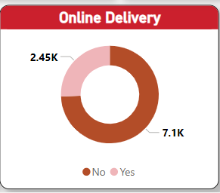

# Table Booking:

* + Only **14% of restaurants** (1,160 out of 9,551) offer table booking services.
  + This suggests that while dine-in is still a preferred option for some customers, many restaurants are yet to embrace table reservation systems.

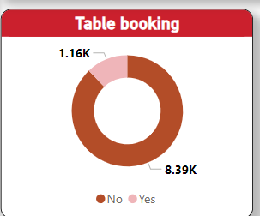

# Service Disparities:

* + Cities with higher delivery penetration, such as New Delhi and Bangalore, outperform smaller cities like Ahmedabad, where table bookings are less common.
  + Restaurants with both services tend to have better customer ratings, suggesting these features enhance the overall dining experience.

# Customer Preferences:

* + Delivery-oriented restaurants tend to receive higher votes and more frequent reviews, emphasizing the importance of a robust online delivery system.

# City-Wise and Country-Wise Restaurant Analysis

The geographical analysis highlights how restaurants are distributed across cities and countries, revealing hotspots and areas for growth.

# Top Cities by Restaurant Count:

* + **New Delhi**: 5,473 restaurants (dominates with 57% of the total dataset).
  + **Gurgaon**: 1,118 restaurants.
  + **Noida**: 1,080 restaurants.
  + **Other Major Cities**: Bangalore, Mumbai, Hyderabad.

# Underrepresented Cities:

* + Cities like **Ahmedabad**, **Chennai**, and **Pretoria** have significantly fewer restaurants compared to metro cities, highlighting opportunities for growth.

# Country Insights:

* + **India**: Dominates the dataset, reflecting Zomato’s strong market penetration.
  + **Other Countries**: Australia, Canada, Singapore, and South Africa have a smaller presence, presenting growth opportunities.

# Regional Popularity:

* + North Indian and Chinese cuisines dominate across most regions, whereas cuisines like Japanese or Vegan are more prevalent in countries outside India.

# Customer Ratings by Cuisines and Restaurants

Customer ratings are a critical indicator of restaurant performance and satisfaction levels:

# Average Ratings:

* + The overall average rating across all restaurants is **2.89 out of 5**, reflecting a moderate level of satisfaction.
  + Restaurants offering both online delivery and table booking generally achieve higher ratings.

# Cuisine Ratings:

* + **Top-Rated Cuisines**:
    - North Indian (3.2), Chinese (3.1), and Desserts (3.0) tend to have better ratings due to their widespread appeal.

# Lower-Rated Cuisines:

* + - Fast Food (2.6) and Bakery (2.5) ratings suggest room for improvement in quality or variety.

# Top Restaurant Chains by Ratings:

* + **McDonald’s** leads with a rating of **3.36**, followed by **Subway** (2.94).
  + **Domino’s Pizza** (2.80) and **Cafe Coffee Day** (2.61) have moderate ratings, suggesting the need for customer satisfaction improvements.

# Votes and Reviews:

* + Restaurants with higher votes generally have better ratings, indicating that popularity and customer trust go hand-in-hand.
  + Average ratings tend to improve in cities with a higher number of votes, showing an active and engaged customer base.

# Summary of Insights:

* Zomato’s platform has a robust restaurant and cuisine presence, with untapped opportunities in niche cuisines and underrepresented cities.
* Online delivery is the most influential service feature, but table booking adoption remains low.
* Customer ratings reflect moderate satisfaction, with scope for improvement in both quality and service offerings, especially for lower-performing cuisines and chains.
* Expanding operations in smaller cities and encouraging underrepresented cuisines can further enhance Zomato’s reach and reputation.

# Dashboard Design and Visualization

This section provides a comprehensive overview of the processes involved in designing, developing, and deploying a dashboard for Zomato’s restaurant analysis. The goal is to create an intuitive, visually appealing, and actionable dashboard using Microsoft Power BI to meet user requirements and provide actionable insights.

# Requirement Gathering and Data Preparation

# Stakeholder Interviews

Stakeholder interviews were conducted to gather requirements and ensure the dashboard meets user expectations. Key stakeholders included:

* + - * **Zomato’s Business Analysts**: Focused on metrics like restaurant distribution, customer ratings, and cuisine popularity.
      * **Marketing Teams**: Required insights into underrepresented cuisines and cities for targeted campaigns.
      * **Restaurant Partners**: Interested in performance metrics like customer reviews, ratings, and order volumes.
      * **Executive Management**: Desired a high-level overview of Zomato’s operations, including total restaurant counts, top-performing regions, and service penetration.

# Key Findings from Interviews:

* + - * **Metrics Identified**: City-wise restaurant counts, cuisine distribution, service availability (delivery and table booking), and average ratings.
      * **Visual Preferences**: Use of bar charts for city-wise performance, pie charts for service adoption, and line charts for trend analysis.
      * **Interactivity Needs**: Filters for city, cuisine, and service type to allow dynamic data exploration.

# Market Benchmarking for Design

Benchmarking was conducted to study dashboards from competitors and industry leaders in the food tech domain. Insights included:

* + - * **Visual Hierarchy**: Top metrics like total restaurants, average ratings, and service availability should be prominently displayed.
      * **Interactive Features**: Filters for dynamic analysis, such as year, location, and service type.
      * **Color Coding**: Use consistent and intuitive colors for categories (e.g., green for high performance, red for low).

Benchmarked dashboards included elements such as:

* + - * Interactive maps for geographic analysis.
      * Slicers for cuisine and service type segmentation.
      * KPI cards for key performance indicators like ratings and restaurant counts.

# Prototyping and Development

# Report Design Process

The dashboard was built on a foundation of reports created in Power BI Desktop. The report design followed these steps:

1. **Data Modeling**: Relationships between tables (e.g., restaurant details, ratings, and services) were established to enable meaningful visualizations.
2. **Defining Metrics**: Key metrics like "Total Restaurants," "Average Ratings," and "Service Penetration" were calculated using DAX (Data Analysis Expressions) formulas.
3. **Filters and Slicers**: Interactive filters for city, cuisine, and service availability were added to allow users to refine their views.

# Visual Selection:

* + **Bar Charts** for city-wise restaurant distribution.
  + **Pie Charts** for service availability.
  + **Line Charts** for ratings trends over time.

1. **Layout Design**: Reports were designed to display critical information at the top, with detailed insights in subsequent sections.

# Dashboard Interface Development

Once reports were designed, a dashboard interface was created using pinned visuals from the reports. The design emphasized:

* + - * **Top-Level KPIs**: Key metrics like "Total Restaurants" and "Average Ratings" prominently displayed as cards at the top.
      * **Geographic Insights**: Interactive maps to visualize restaurant distribution and service penetration by city.
      * **Trend Analysis**: Line charts for ratings trends and service adoption over time.
      * **User-Friendly Navigation**: Clean, uncluttered layout with easy-to-read fonts and consistent color themes.

# Dashboard Deployment Process

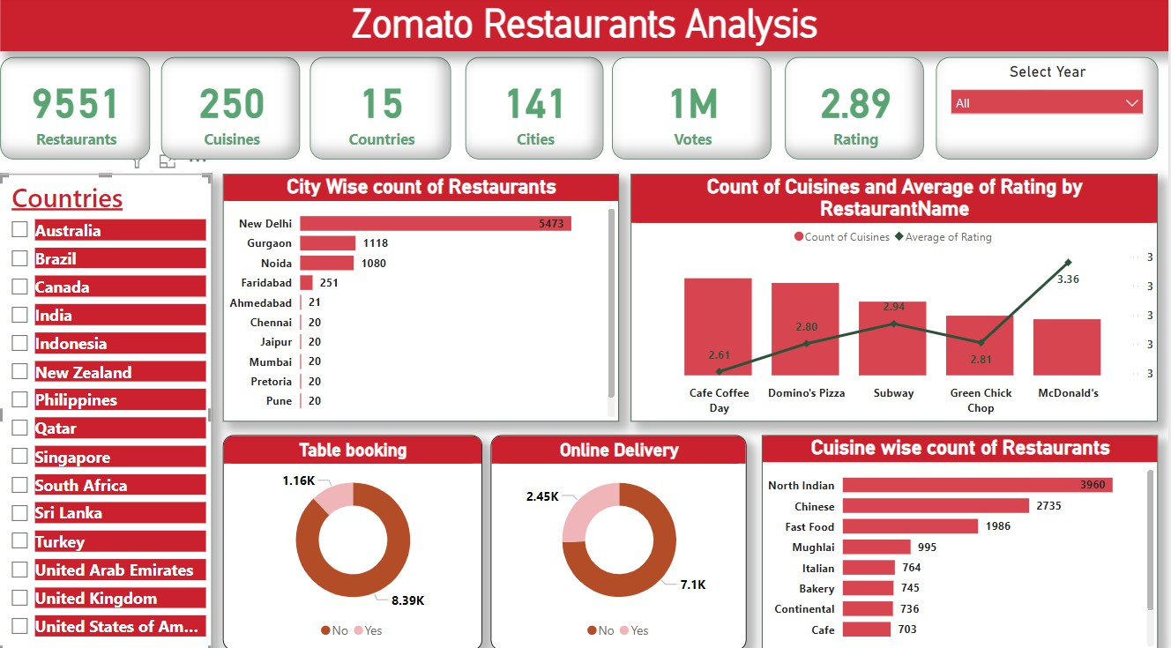

# Data Integration

Data integration was critical to ensure accurate and up-to-date insights:

1. **Data Source Connectivity**: Power BI connected to datasets stored in cloud storage (e.g., Microsoft OneDrive) for real-time updates.
2. **Data Refresh**: A schedule was set to automatically refresh data every hour, ensuring the dashboard reflected the latest figures.
3. **Data Validation**: Cleaned and transformed data was cross-verified with raw data sources for consistency and accuracy.

# Creating and Publishing Reports

Reports were published to the Power BI Service for sharing and collaboration:

* + - * **Publishing Process**: Reports were uploaded to the Power BI workspace and organized into dashboards.
      * **Access Control**: Role-based permissions were applied to ensure secure access for specific teams and stakeholders.

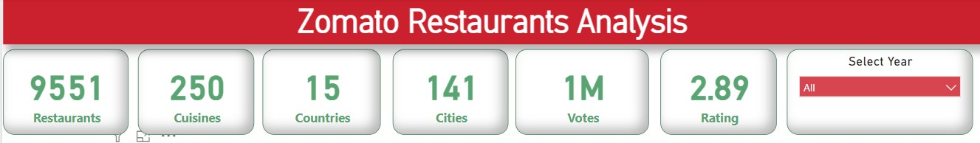

# Mobile-Optimized Dashboards

Recognizing the need for accessibility on the go:

* + - * **Responsive Design**: Dashboards were optimized for mobile devices, with rearranged visuals and simplified layouts.
      * **Testing**: The mobile experience was tested on various screen sizes to ensure usability.

# Evaluation and Improvements

To ensure the dashboard met user expectations, an evaluation phase was conducted:

1. **Feedback Collection**: Feedback was gathered from stakeholders after deployment. Key areas of focus included:
   * Clarity and comprehensiveness of visuals.
   * Ease of navigation and interaction.
   * Relevance of displayed metrics.

# Iterative Improvements:

* + Additional filters were added based on user requests (e.g., cuisine type filters for city- specific analysis).
  + Visuals were refined for better readability, such as larger font sizes for key metrics and improved color contrast.
  + Annotations were added to charts to highlight critical trends, like the top-performing cities.

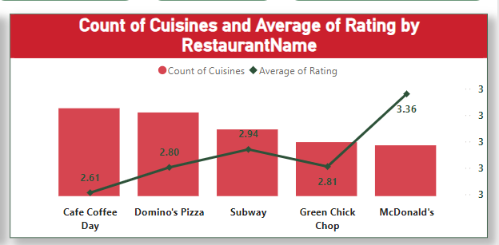

# Conclusion and Recommendations

# Summary of Key Findings

The analysis of Zomato’s restaurant dataset provided several valuable insights into the platform's operations, customer preferences, and market dynamics. Key findings are summarized as follows:

# Restaurant and Cuisine Insights:

* + Zomato hosts **9,551 restaurants**, offering over **250 cuisines** across **141 cities in 15 countries**.
  + **North Indian** and **Chinese cuisines** dominate the restaurant offerings, while cuisines like

**Bakery** and **Cafe** are underrepresented.

* + Chain restaurants like **McDonald’s** and **Subway** receive high ratings, while independent restaurants have more variability in customer satisfaction.

# Service Trends:

* + **Online delivery** is widely adopted, with 74% of restaurants offering the service, making it the most prominent feature on the platform.
  + **Table booking** is less common, available in only 14% of restaurants, indicating untapped potential for dine-in convenience.
  + Restaurants offering both services tend to achieve higher customer ratings and attract more votes.

# Geographic Performance:

* + **New Delhi** leads in restaurant count, contributing 57% of the total dataset. Other cities like Gurgaon and Noida also perform well.
  + Smaller cities such as **Ahmedabad** and **Chennai** have fewer restaurants, highlighting growth opportunities in these regions.
  + **India dominates** the dataset, with limited representation from countries like Australia, Singapore, and South Africa.

# Customer Ratings and Preferences:

* + The overall average rating is **2.89/5**, reflecting moderate customer satisfaction.
  + Ratings are generally higher for restaurants offering diverse cuisines and delivery options.
  + Popular cuisines like **North Indian** and **Chinese** have better ratings compared to niche cuisines, indicating strong customer demand for these categories.

# Suggestions for Business Strategy

Based on the findings, several recommendations are provided to improve Zomato’s operations, enhance customer satisfaction, and drive business growth:

# Expand Service Offerings:

* + **Increase Table Booking Availability**: Encourage more restaurants to offer table booking services to cater to customers who prefer planned dine-in experiences.
  + **Enhance Online Delivery Reach**: Focus on onboarding restaurants in smaller cities to expand the online delivery network and capture untapped demand.

# Focus on Underserved Cities and Regions:

* + **Geographic Expansion**: Target underrepresented cities like Ahmedabad, Chennai, and Pretoria for strategic growth. Offer incentives for new restaurant partners in these areas.
  + **International Markets**: Strengthen Zomato’s presence in countries like Australia and South Africa to diversify its customer base and reduce dependence on the Indian market.

# Improve Customer Ratings:

* + **Quality Control Initiatives**: Work closely with restaurants to ensure consistent food quality and timely delivery, particularly in lower-rated establishments.
  + **Customer Engagement**: Leverage customer reviews to identify specific pain points and address common complaints, such as inaccurate orders or delivery delays.

# Diversify Cuisine Offerings:

* + Promote niche and underrepresented cuisines like **Bakery** and **Cafe** in regions where demand exists.
  + Collaborate with restaurants to introduce trendy cuisines (e.g., Vegan, Japanese) in high- demand urban centers.

# Leverage Data for Personalized Marketing:

* + Use customer data to provide targeted recommendations based on past orders, location, and cuisine preferences.
  + Roll out campaigns for high-demand cuisines or restaurant promotions to drive customer engagement.

# Enhance Business Intelligence Capabilities:

* + Use dynamic dashboards like the one developed in this report to monitor trends in real-time and adjust strategies accordingly.
  + Implement predictive analytics to forecast demand for cuisines, services, and regions during specific times or events.

# Collaborate with Restaurant Partners:

* + Share performance insights with restaurant owners to help them optimize menu offerings, pricing strategies, and customer service.
  + Offer training and resources to improve delivery and service efficiency, especially for restaurants with below-average ratings.

# References

1. **Zomato. (2023).** *About Us*. Zomato. Retrieved from https://[www.zomato.com/about](http://www.zomato.com/about)
   * This is the official Zomato page that provides background information about the company, its services, and the countries and cities it operates in.
2. **Vercellis, C. (2009).** *Business Intelligence: Data Mining and Optimization for Decision Making*. Wiley-Interscience.
   * Vercellis' work provides a thorough understanding of business intelligence (BI), covering various techniques such as data mining and optimization that are essential for informed decision-making, especially in a platform like Zomato.
3. **Microsoft. (2018).** *Power BI Documentation*. Microsoft. Retrieved from <https://docs.microsoft.com/en-us/power-bi/>
   * This documentation offers detailed information on how to use Microsoft Power BI, the tool used in this report to analyze and visualize Zomato's data.
4. **Loshin, D. (2003).** *Business Intelligence: The Savvy Manager's Guide*. Elsevier.
   * A comprehensive guide to business intelligence concepts, illustrating how businesses can leverage data for analysis and decision-making, which is relevant for understanding the role of BI at Zomato.
5. **Delen, D., Sharda, R., & Turban, E. (2014).** *Business Intelligence and Analytics: Systems for Decision Support*. Pearson Education.
   * This book dives into various BI systems, analytics, and decision support, providing foundational knowledge for understanding how BI tools can help improve restaurant performance and customer service on platforms like Zomato.
6. **Catarci, T., Dix, A., Kimani, S., & Santucci, G. (2010).** *User-Centric Design in Information Systems*. Springer.
   * This text explains user-centric design principles, which were applied in developing the dashboard for Zomato. The goal was to ensure that the dashboard met the specific needs and preferences of Zomato's stakeholders.
7. **IBM. (2016).** *The Impact of Data on Business Decisions*. IBM Analytics. Retrieved from https:/[/www.ibm.com/](http://www.ibm.com/analytics)a[nalytics](http://www.ibm.com/analytics)
   * This report outlines how data analytics and business intelligence can help organizations like Zomato make better decisions, particularly when dealing with large datasets.
8. **Power BI Team. (2020).** *Interactive Dashboards: Best Practices*. Microsoft Power BI Blog. Retrieved from https://community.powerbi.com/t5/Power-BI-Blog/Best-practices-for-Power-BI- dashboards/ba-p/1109789
   * This blog post from the Power BI team discusses best practices for designing interactive

dashboards, which were essential in the creation of Zomato’s restaurant analysis dashboard.

1. **Patterson, C., & Keppler, M. (1996).** *Benchmarking for Performance Improvement*. CRC Press.
   * This resource covers benchmarking, an essential process for understanding how Zomato's restaurant offerings compare to competitors. This was integral in understanding industry standards and designing features that would enhance Zomato’s performance.
2. **Brinkmann, S. (2013).** *Qualitative Interviewing: Understanding Qualitative Research*. Oxford University Press.

* Brinkmann's book provides guidance on qualitative interviewing, a technique used to gather insights from stakeholders regarding their dashboard needs and expectations.

1. **Saldana, J. (2009).** *The Coding Manual for Qualitative Researchers*. Sage Publications.

* Saldana’s manual helped guide the qualitative data analysis process during the interview phase, ensuring that themes and patterns were identified and translated into actionable insights.

1. **Lapointe, L. (2008).** *Effective Business Intelligence Systems: A Focus on User-Centric Design*. Journal of Information Technology.

* This article discusses the importance of user-centric design in BI systems, providing key insights into making the dashboard not just informative, but also intuitive and user-friendly for Zomato’s stakeholders.

1. **The History of BI: The 2000’s and Now. (2014).** *Business Intelligence Revolution*. Retrieved from <https://www.panorama.com/blog/history-business-intelligence>

* A history of business intelligence that details the evolution of BI systems, offering context on why tools like Power BI are integral to modern data analysis.

1. **Watson, H. (2011).** *The Next Generation of Business Intelligence: Tools and Techniques*. Wiley.

* This book explores the latest trends in BI tools, such as Power BI, which were employed in this project to analyze and visualize data for Zomato’s strategic decisions.